WORKFORCE COMPENSATION ANALYSIS SQL QUERIES
1. TOTAL EMPLOYEES COUNT
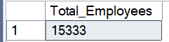

2. AVERAGE SALARY AND TOTAL COMPENSATION OVERVIEW
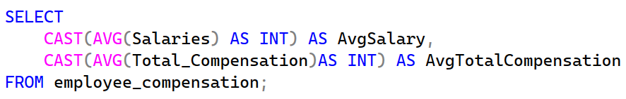

3. AVERAGE TOTAL COMPENSATION ACROSS DEPARTMENTS.
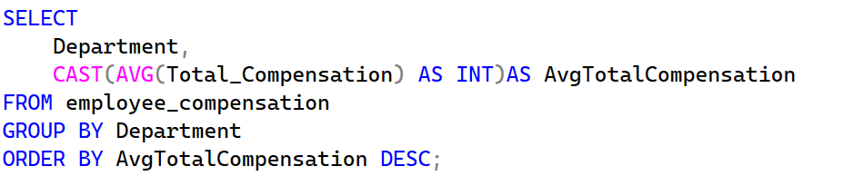
.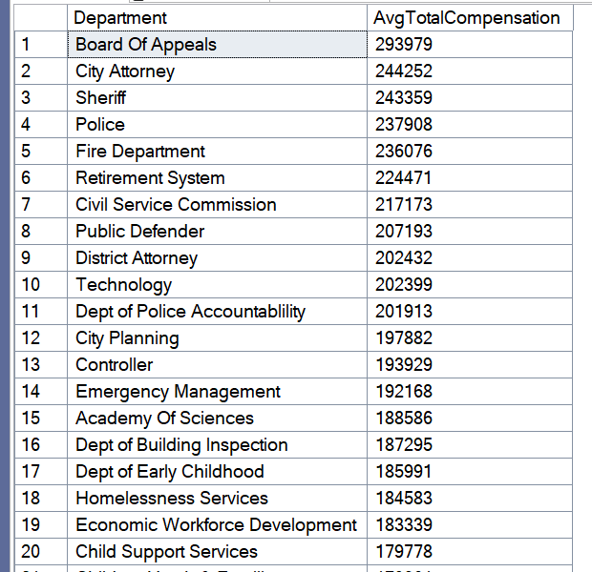
4. DEPARTMENTAL OVERTIME COST
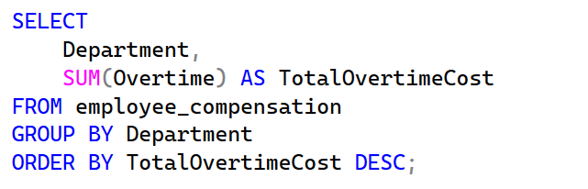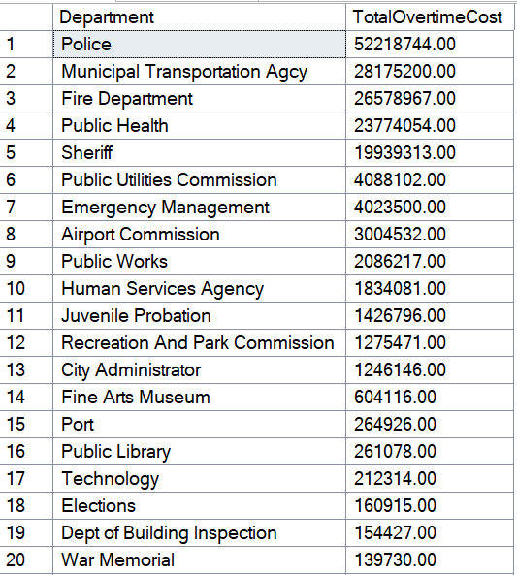

5. EMPLOYMENT TYPE COMPENSATION BREAKDOWN
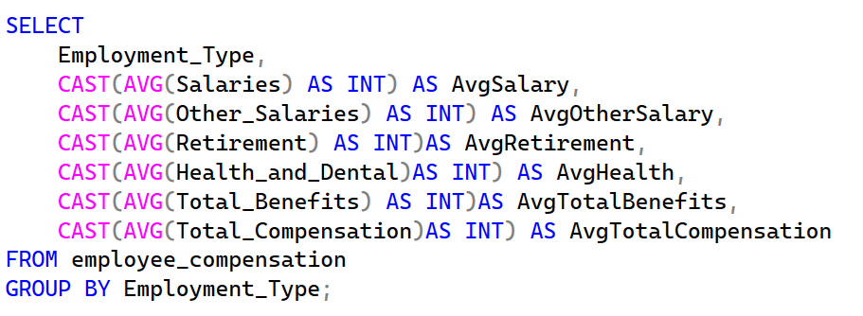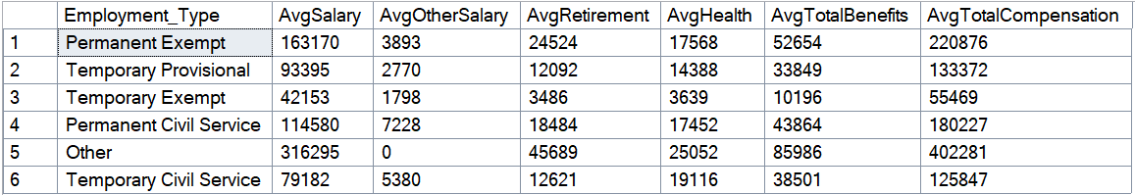

6. AVERAGE PAY ACROSS DIFFERENT JOB FAMILIES.
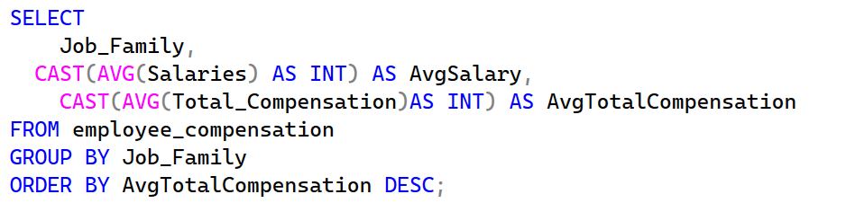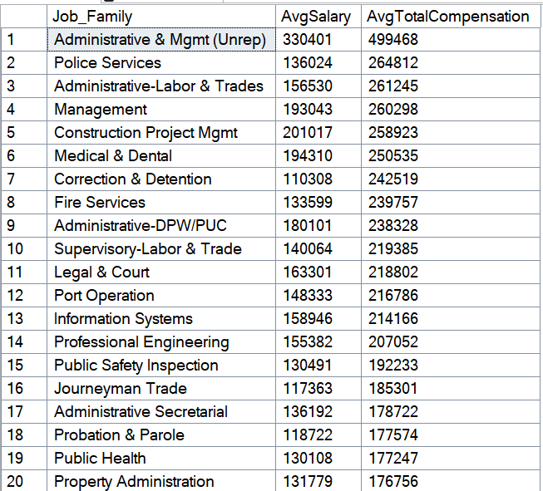

7. TOP 10 HIGHEST PAID JOB TITLES
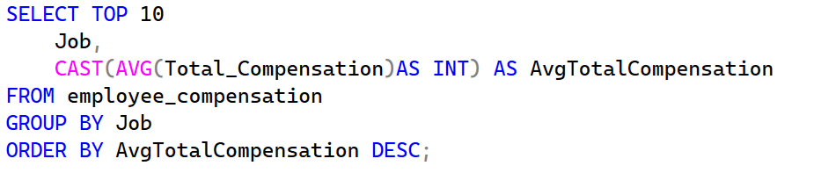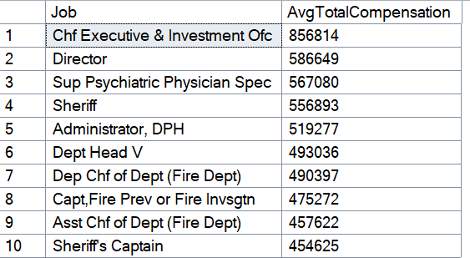
8. OVERTIME AS % OF TOTAL COMPENSATION
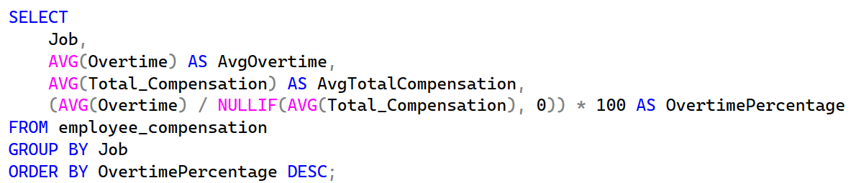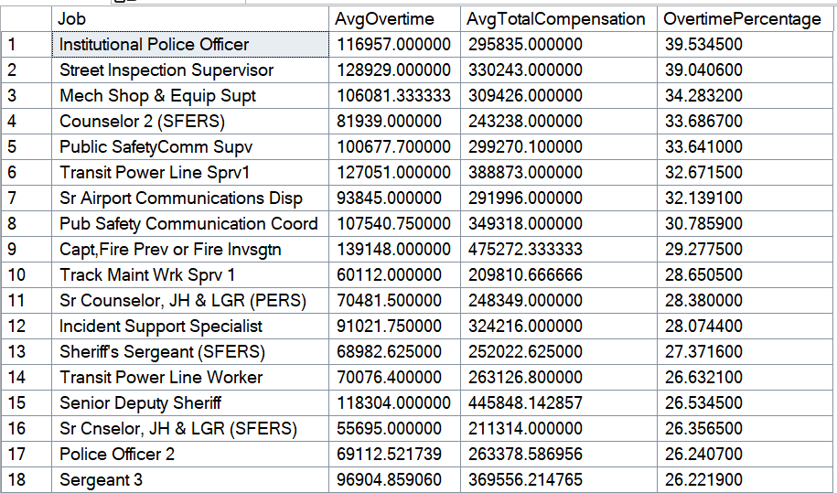

9. TOTAL COMPENSATION BY UNION CODE
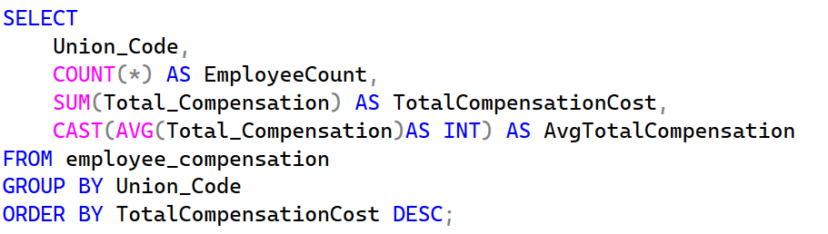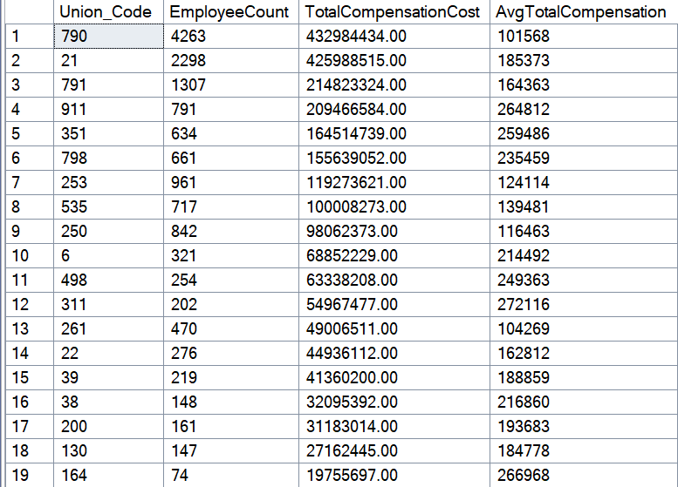

10. BENEFITS AS % OF TOTAL COMPENSATION
